# EurekaSim Backup Addin Usage

**Prerequisites**

* .NET 4.5.2 or above needs to be installed in your computer.
* EurekaSim Application.

**Instructions**

1. Install **EurekaSim Backup Addin** by double clicking Eurekasim_Backup_Setup and follow the instructions until ‘finish’. You can change destination folder and installation type if you want.
2. Open your **EurekaSim** Application and there you can see **EurekaSim WebCloud Addin.**

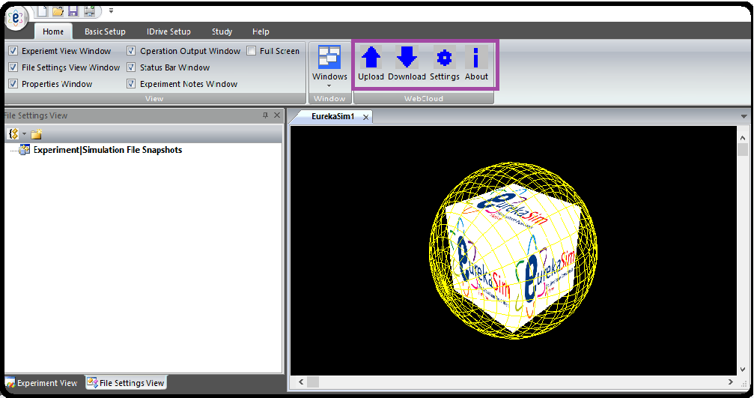

1. To use EurekaSim Backup Addin, first you need to login to your EurekaSim account. Click the settings button and then you need to enter your email id and password of EurekaSim account. Click login button to login to your account.

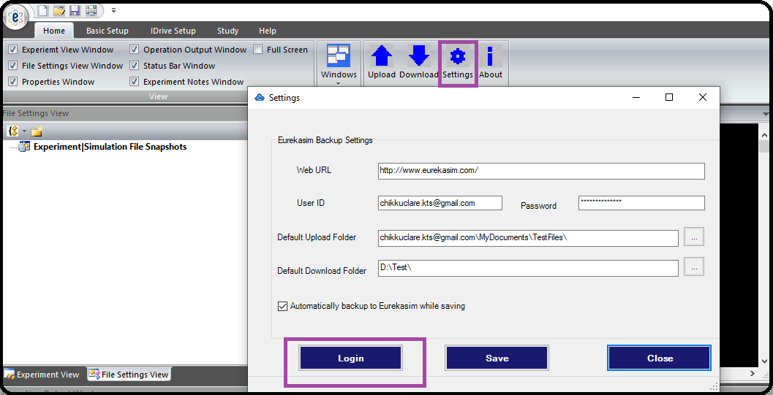

1. After login, you can see your EurekaSim account name below your settings dialog. You can set the default upload location, default download location and whether you need to upload files automatically while saving.
2. Now, to manually upload a file to your EurekaSim account, you need to click upload button from ribbon bar. If you saved your current active file before uploading, it will be shown as the file for uploading. You can browse and change it if you want. You can also change the EurekaSim upload location from its default value if you want. Then click upload.

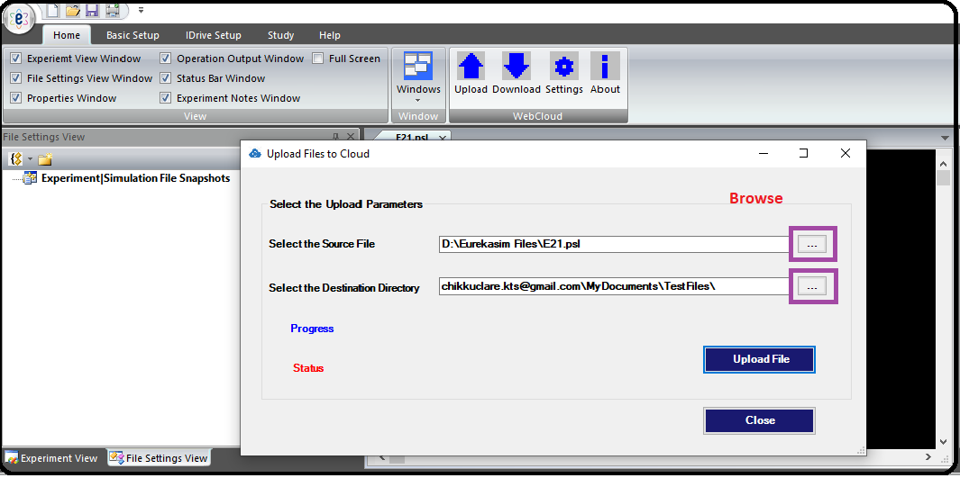

1. For downloading a file from EurekaSim, you need to click on Download button from ribbon bar. It will show the download dialog where you need to browse and select the downloading file. You can also check the ‘open after download’ option if you need to open the file after download. Then you need to click the Download button and then the file starts downloading.

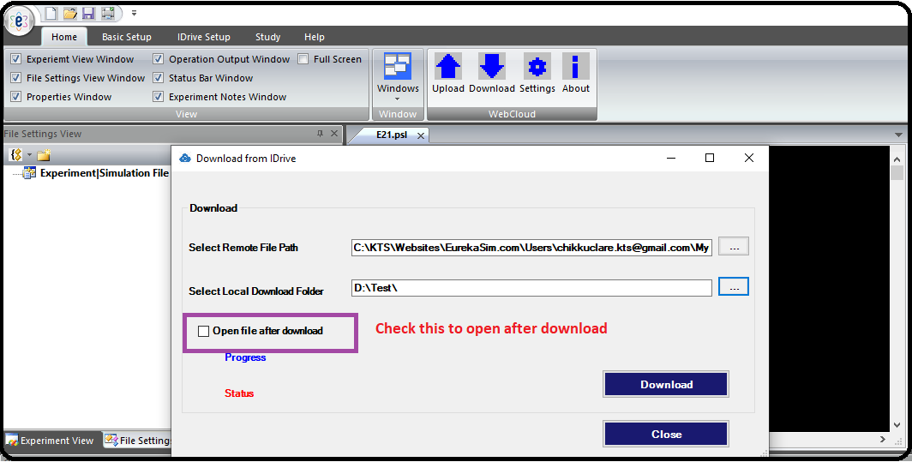

Note : Clicking About button from the toolbar will show the details of the author of EurekaSim Backup Addin.

Instruction video link: <https://youtu.be/V4FrlY3i6cc>